Project Design Phase-II
Data Flow Diagram & User Stories

Date | 28 oct 2026
Team ID
Project Name | Global Olympic Sports Performance Analysis
Maximum Marks | 4 Marks

Data Flow Diagrams:
A Data Flow Diagram (DFD) is a traditional visual representation of the information flows within a system. A neat and clear DFD can depict the right amount of the system requirement graphically. It shows how data enters and leaves the system, what changes the information, and where data is stored.
DFD Symbol Legend
Symbol | Name | Description
Oval / Rounded  shape | External Entity | A person, organization, or system outside the project that sends or receives data (e.g., Customer, Payment Gateway).
Rectangle with  numbered header | Process | An activity that transforms incoming data into outgoing data (e.g., Validate Request, Process Order).
Rectangle (solid fill, no number) | Data Store | A place where data is held for later use (e.g., Customer Database, Inventory).
Labeled arrow | Data Flow | The movement of data between entities, processes, and data stores, labeled with what data is being passed.

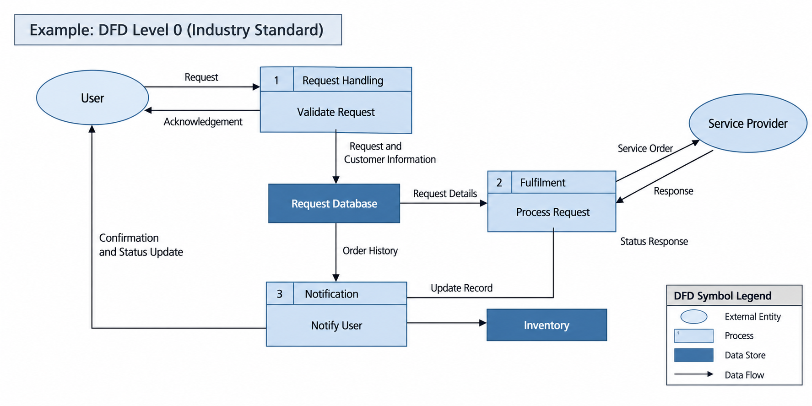

Data Flow Diagram – Level 1
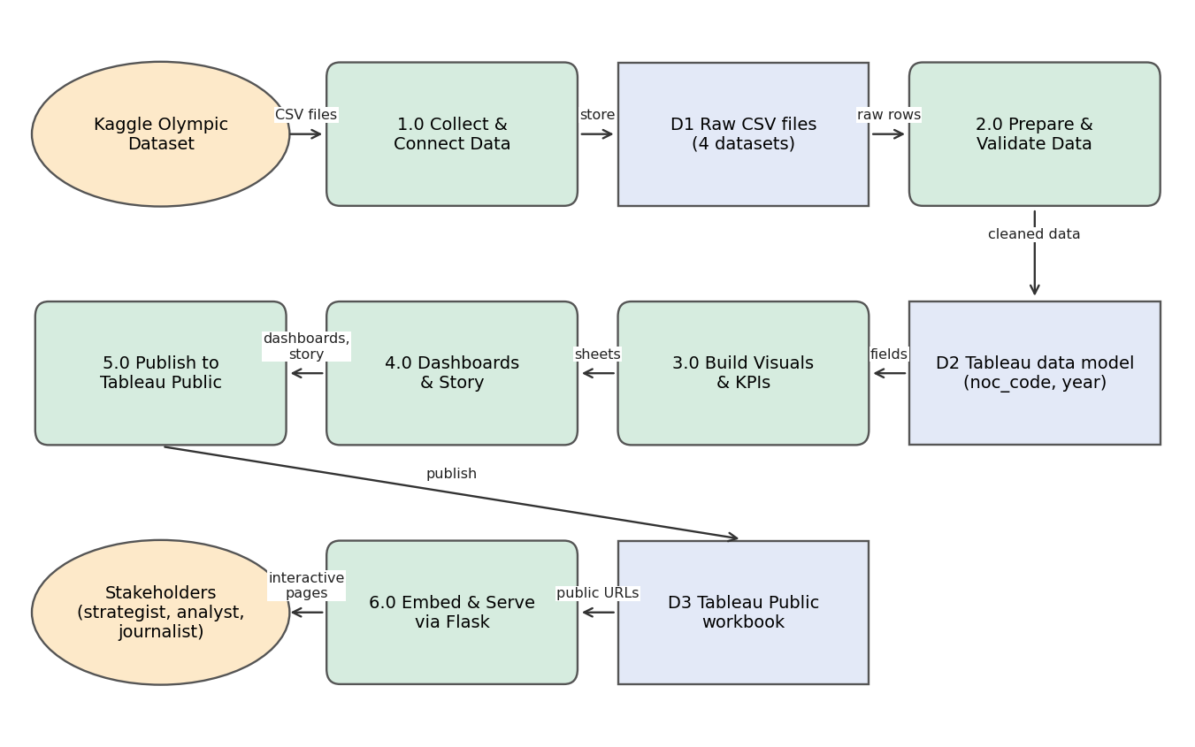

User Stories
Use the below template to list all the user stories for the product.
User Type | Functional Requirement (Epic) | User Story Number | User Story / Task | Acceptance criteria | Priority | Release
Performance Strategist (Priya) | Dashboard Viewing | USN-1 | As a strategist, I can see average medals per athlete by sport category so that I can pick high-yield disciplines. | Horizontal bar chart is shown and sorted by value; sport category filter updates it. | High | Sprint-2
Performance Strategist (Priya) | Dashboard Viewing | USN-2 | As a strategist, I can compare my country with top performers on total, gold, silver and bronze medals. | KPI selector switches the country bar chart between the four measures. | High | Sprint-2
Investment Analyst (Carlos) | Investment Analysis | USN-3 | As an analyst, I can see sports investment against medal performance by country to spot over- and under-performers. | Bubble chart is shown with country labels and tooltips. | High | Sprint-3
Investment Analyst (Carlos) | Investment Analysis | USN-4 | As an analyst, I can compare average medal efficiency % by region to guide grant decisions. | Pie chart is shown; region filter updates Dashboard 2. | High | Sprint-3
Data Journalist (William) | Storytelling | USN-5 | As a journalist, I can view the trend of total medals awarded by Games year. | Line chart shows each Games year from 1992 to 2026. | Medium | Sprint-2
Data Journalist (William) | Storytelling | USN-6 | As a journalist, I can compare medal totals across Olympic host nations. | Horizontal bar chart is shown; host country filter works. | Medium | Sprint-3
Data Journalist (William) | Storytelling | USN-7 | As a journalist, I can step through a Tableau story of key insights. | Story page loads and each scene can be navigated. | Medium | Sprint-4
Any user | Filtering | USN-8 | As a user, I can filter by country, year and sport category (Dashboard 1) and by region and host country (Dashboard 2). | All charts on the dashboard update together. | High | Sprint-2
Any user | Overview | USN-9 | As a user, I can read KPI tiles (participation, nations, sport categories, regional efficiency) at a glance. | KPI tiles are visible at the top of each dashboard. | Medium | Sprint-2
Web visitor | Web Access | USN-10 | As a visitor, I can open the website and reach the dashboard and story pages from a menu. | Home, Dashboard and Story pages load without errors. | High | Sprint-4
Developer / Administrator | Data & Publishing | USN-11 | As the administrator, I can update the workbook and republish it to Tableau Public. | Published URLs still render in the Flask pages after republishing. | Medium | Sprint-4
Developer / Administrator | Data & Publishing | USN-12 | As the administrator, I can prepare the data (types, nulls, relationships) before visualising. | Validation checks listed in Data Preparation are completed. | High | Sprint-1

